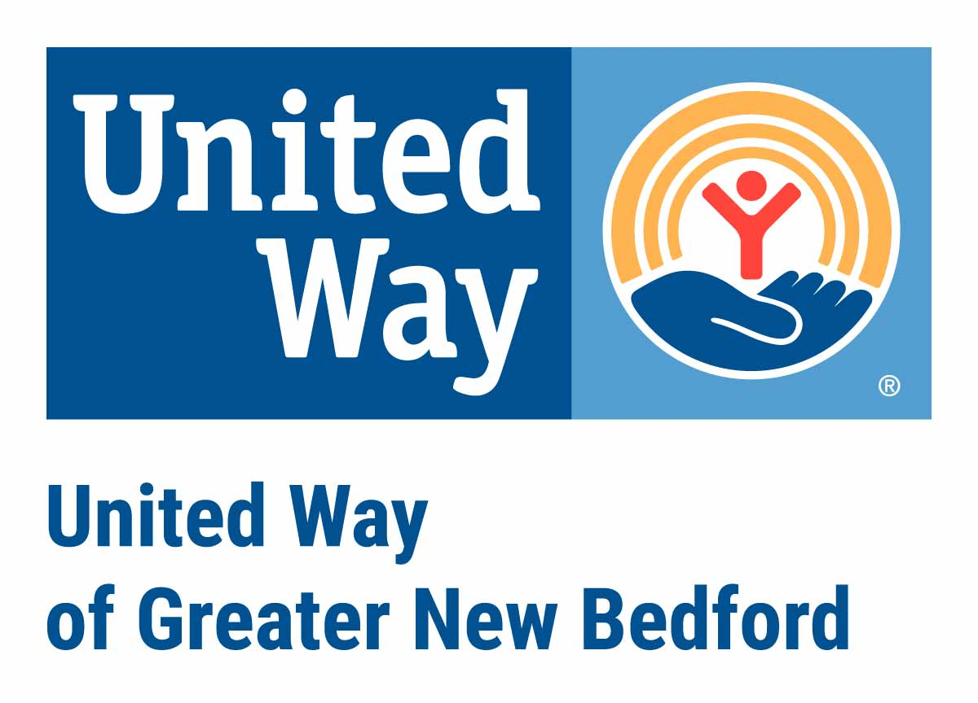
Emergency Food and Shelter Program
Phase 41
Request for Funding Checklist & Application

Bristol County has been awarded $248,172 for Phase 41 to supplement emergency food and shelter programs in the county. The federal department responsible for this program is the Department of Homeland Security’s Federal Emergency Management Agency (FEMA) – these are not state/county government or United Way Funds. United Way of Greater New Bedford serves as the local manager for Bristol County.

Under the terms of the grant from the National Board, local agencies chosen to receive funds must:
1) be private voluntary non-profits or units of government, 2) be eligible to receive Federal funds, 3) have an accounting system, 4) practice nondiscrimination, 5) have demonstrated the capability to deliver emergency food and/or shelter programs, and 6) if they are a private voluntary organization, have a voluntary board. Qualifying agencies are urged to apply.

A complete packet of your application & attachments should be submitted to: United Way of Greater New Bedford: 128 Union Street, Suite 105, New Bedford, MA 02740 and received by 4 PM on Friday, September 6, 2024. Additionally, THIS application form MUST also be submitted electronically by email to liveunited@unitedwayofgnb.org (Please note attachments do not need to be emailed.)

Please select which community you are applying for via this application form. If you are applying for more than one community, you will need to fill out an application for each community and program site:

Attleboro Fall River New Bedford Taunton

If you are applying for more than one program site, please fill out an application for EACH program site!
Please type or print neatly:

Applicant Organization (full legal name) _________________________________________

LRO#_______ (if you have received EFSP funding in the past, you have an LRO #, if you have never received funding from EFSP, please leave blank)

Application Contact Person __________________________ Title ____________________

Contact E-Mail _________________________ Contact Phone _______________________

Executive Director __________________________________

ED’s E-Mail ____________________________ ED’s Phone __________________________

Applying agencies must agree to the following:

- Is a Not-For-Profit applicant, has Articles of Incorporation, an exemption from Federal Income Tax under Section 501 ( c) (3) or is exempt from taxation under another section of the Internal Revenue Code. (Please provide most recent copy if applicable)

- Has a current Board of Directors or Voluntary Board. (Please provide List of Board Members with terms of office)

- Has most recent annual certified audit or financial statements (Please provide copies) OR proof of an accounting system.

- Has IRS Form 990 or 990EZ. (Please provide most recent copy if applicable)

- Has a Unique Entity Identifier UEI #: ______________________

- Has stated policies of nondiscrimination and complies with all the requirements of state and Federal laws and regulations on nondiscrimination and equal opportunity with respect to clients, officers, employees and volunteers.

- Does not knowingly employ individuals or contribute funds to organizations found on terrorist-related lists officially announced by the U.S. Government, the United Nations or the European Union.

- Has certification indicating compliance with the spirit and intent of the U.S.A. Patriot Act and other counter terrorism laws as requested.

- Agree to fully complete and submit all EFSP reports.

What amounts are you seeking in Phase 41 in the following categories?

Meals Served:
Other Food:
Mass Shelter:
Other Shelter:
Rents/Mortgages:
Utilities Assistance:

Does your agency receive funding from another EFSP Board? If so, please list amount and board:

Mass Shelter Applicants Only

What is your shelter bed capacity?

What is your bed utilization for last fiscal year?

How many bed nights will be funded by EFSP funds?

For Rent/Mortgage and Utility Assistance Only
NOTE: Rent/Mortgage and Utility funding recipients must be able to demonstrate organizational and case management capacity. Capacity to deliver programs should illustrate the following:

How will the program be marketed to the community?

How will client/customer feedback be encouraged and monitored?

Describe your program capacity to deliver services.

Food Assistance - FOR MASS FEEDING PROGRAMS ONLY
There are two options for eligible costs. One option must be selected at the beginning and continued throughout the phase. Please note the per meal allowance for Phase 37 is $2.00 per meal served. LROs may alternately select direct expense accounting in lieu of a per meal rate.

Does your agency have an established account at the Greater Boston Food Bank? Yes No

Does your organization regularly distribute USDA Food Commodities? Yes No

Briefly describe your food program.

What are your agency's food distribution policies, including how often individuals can receive food?

EFSP Phase 41: Planning and Budgeting Information
The intent of the Emergency Food and Shelter Program is to supplement and expand current available resources and not to substitute or reimburse ongoing programs and services or to start new programs. Services for which funding is being requested must already be provided by your agency through other funding sources.

For each EFSP line item for which you are requesting funding, please reflect other agency funds available and the source of this funding.

Sources of Current Non-EFSP Program Funds
For each item below, click the applicable link to add the source of the non-EFSP program funds and enter the amount of funds for each source. Do not leave fields blank - if an item is not applicable, please enter "0".

Sources of Current Non-EFSP Program Funds | Program Funds
Served Meals
Other Food
Mass Shelter
Rent and Mortgage
Hotel/Motel
Utility
Total

Current Non-EFSP Funds and EFSP Funds Requested

Food

 | Current Program  Non-EFSP Funds | Sources of Current  Non-EFSP Program Funds | EFSP Funds Requested
Served Meals
Other Food
Total
Shelter

 | Current Program  Non-EFSP Funds | Sources of Current  Non-EFSP Program Funds | EFSP Funds Requested
Mass Shelter
Other Shelter
Total

Rent, Mortgage, Utility

 | Current Program  Non-EFSP Funds | Sources of Current  Non-EFSP Program Funds | EFSP Funds Requested
Rent and Mortgage
Utility
Total
Total

 | Current Program  Non-EFSP Funds | Sources of Current  Non-EFSP Program Funds | EFSP Funds Requested
Grand Total All Services
EFSP Phase 41: Program Budget Narrative
If there is a budget deficit, please explain below how your organization will ensure that EFSP funds are not used to meet that deficit. Also, indicate if your organization is able to expend funds if they are released late.

Does your organization have a process or ability to expend funds if released late during the calendar year or term of phase?

If there is a budget deficit, please explain how your organization will ensure that EFSP funds are not used to meet that deficit.

EFSP Phase 41: Additional Program Information* only required for new applicants

If you have never received EFSP dollars in a previous phase, please answer the following questions:

Provide a succinct summary of the key demographic characteristics of program's target population to be served with EFSP funding:

Number of clients currently served without EFSP funding:

Provide a general description of program activities and processes used by the agency to deliver services:

How will the EFSP funds be used to enhance the current services?

How will services be coordinated with other programs within your agency and within the community?

Describe the eligibility criteria for individuals requesting services and how is this documented:

___________________________________ _______________
Signature of contact filling this application Date

___________________________________
Name of Executive Director/President/CEO

______________________________________ _______________
Signature of Executive Director/President/CEO Date

Your submission is considered complete when this application AND requested attachments are received to UWGNB by 9-6-24 @ 4pm. Additionally, this completed application form must also be emailed to: liveunited@unitedwayofgnb.org

